Aim: To obtain the classification of various classes using k-Nearest Neighbor approach IDE: Google Colab
Theory:
This algorithm is used to solve the classification model problems. K-nearest neighbor or K-NN algorithm basically creates an imaginary boundary to classify the data. When new data points come in, the algorithm will try to predict that to the nearest of the boundary line. Therefore, larger k value means smother curves of separation resulting in less complex models. Whereas, smaller k value tends to over fit the data and resulting in complex models. It’s very important to have the right k-value when analyzing the dataset to avoid over fitting and under fitting of the dataset.

The model representation for KNN is the entire training dataset. It is as simple as that. KNN has no model other than storing the entire dataset, so there is no learning required. Efficient implementations can store the data using complex data structures like k-d trees to make look-up and matching of new patterns during prediction efficient. Because the entire training dataset is stored, you may want to think carefully about the consistency of your training data. It might be a good idea to curate it, update it often as new data becomes available and remove erroneous and outlier data.

K-NN algorithm assumes the similarity between the new case/data and available cases and put the new case into the category that is most similar to the available categories. K-NN algorithm stores all the available data and classifies a new data point based on the similarity. This means when new data appears then it can be easily classified into a well suite category by using K- NN algorithm. K-NN algorithm can be used for Regression as well as for Classification but mostly it is used for the Classification problems.

K-NN is a non-parametric algorithm, which means it does not make any assumption on underlying data. It is also called a lazy learner algorithm because it does not learn from the training set immediately instead it stores the dataset and at the time of classification, it performs an action on the dataset. KNN algorithm at the training phase just stores the dataset and when it gets new data, then it classifies that data into a category that is much similar to the new data.

Example: Suppose, we have an image of a creature that looks similar to cat and dog, but we want to know either it is a cat or dog. So for this identification, we can use the KNN algorithm, as it works on a similarity measure. Our KNN model will find the similar features of the new data set to the cats and dogs images and based on the most similar features it will put it in either cat or dog category.

Methodology:
- Load the basic libraries and packages
- Load the dataset
- Analyse the dataset
- Pre-process the data
- Visualize the Data
- Separate the feature and prediction value columns
- Select the number K of the neighbors
- Calculate the Euclidean distance of K number of neighbors
- Take the K nearest neighbors as per the calculated Euclidean distance.
- Among these k neighbors, count the number of the data points in each category.
- Assign the new data points to that category for which the number of the neighbor is maximum.
- Our model is ready.
Pre Lab Exercise:

- What is K in KNN-approach?
- K represents the number of nearest neighbors considered for classification________
- It determines how many nearby data points influence the prediction______________
Example:________________________________________________________________
If K = 3 → classification is based on the majority of 3 nearest points_________________ ________________________________________________________________________

- Which are the types of distance metrices?
- Euclidean Distance (most common)________________________________________
- Manhattan Distance____________________________________________________
- Minkowski Distance____________________________________________________
- Hamming Distance (for categorical data)____________________________________
________________________________________________________________________ c. What can be the criteria of selection of the value of K?
- Avoid too small K (overfitting)_____________________________________________
- Avoid too large K (underfitting)____________________________________________
- Use odd values (to avoid ties)____________________________________________
- Use cross-validation to find optimal K_____________________________________
________________________________________________________________________ d. What are the advantages of KNN algorithm?
- Simple and easy to understand____________________________________________
- No training phase (lazy learner)____________________________________________
- Works well for small datasets______________________________________________
- Can handle multi-class problems___________________________________________
________________________________________________________________________

Program (Code):
To be attached with
# Step 1: Import libraries
import numpy as np
import pandas as pd
import matplotlib.pyplot as plt
import seaborn as sns

from sklearn.model_selection import train_test_split
from sklearn.neighbors import KNeighborsClassifier
from sklearn.metrics import confusion_matrix, accuracy_score

# Step 2: Load dataset (Iris dataset)
from sklearn.datasets import load_iris
data = load_iris()

X = data.data
y = data.target

# Step 3: Split dataset
X_train, X_test, y_train, y_test = train_test_split(X, y, test_size=0.2)

# Step 4: Apply KNN
k = 5
model = KNeighborsClassifier(n_neighbors=k)
model.fit(X_train, y_train)

# Step 5: Predictions
y_pred = model.predict(X_test)

# Step 6: Confusion Matrix
cm = confusion_matrix(y_test, y_pred)
print("Confusion Matrix:\n", cm)

# Step 7: Accuracy
accuracy = accuracy_score(y_test, y_pred)
print("Accuracy:", accuracy)

# Optional: Heatmap
sns.heatmap(cm, annot=True)
plt.title("Confusion Matrix")
plt.show()

Results:
To be attached with
- Confusion matrix
• Shows correct and incorrect predictions
• Diagonal values = correct classifications
- Accuracy Score
• Accuracy = Correct Predictions / Total Predictions
• Typically high for Iris dataset (~90–100%)

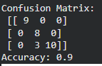
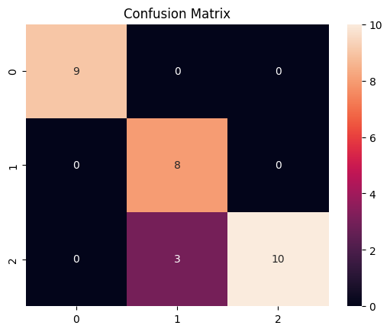
Observation and Result Analysis:
- Nature of the dataset
- Dataset contains multiple classes__________________________________________
- Features are numerical__________________________________________________
- Classes are separable____________________________________________________
________________________________________________________________________

- During Training Process
- No actual training (lazy learning)__________________________________________
- Model stores entire dataset______________________________________________
- Distance calculations happen during prediction_______________________________
________________________________________________________________________

- After the training Process
- Model classifies new data based on neighbors________________________________
- Accuracy depends on K value______________________________________________
- Works well for small datasets______________________________________________
________________________________________________________________________

- Observation over the Learning Curve
- Small K → high variance (overfitting)________________________________________
- Large K → high bias (underfitting)__________________________________________
- Optimal K gives best accuracy_____________________________________________
________________________________________________________________________
Post Lab Exercise:
a. Is KNN useful in regression-based problems?
Yes, KNN can be used for regression by averaging values of nearest neighbors.
_______________________________________________________________________
________________________________________________________________________ b. Why KNN is a non-parametric algorithm?
- It does not assume any underlying data distribution___________________________
- No fixed model equation_________________________________________________
________________________________________________________________________

- What are the assumptions of KNN approach?
- Similar data points exist close to each other__________________________________
- Distance metric correctly represents similarity_______________________________
- Data is properly scaled__________________________________________________
________________________________________________________________________
- How can the KNN approach make the prediction of the unseen dataset?
- Calculate distance from new point to all training data__________________________
- Select K nearest neighbors________________________________________________
- Perform majority voting__________________________________________________
- Assign class____________________________________________________________
________________________________________________________________________ e. Why is KNN called a Lazy Learner?
- No training phase_______________________________________________________
- Stores data and computes during prediction__________________________________
________________________________________________________________________ f. Why should we not use KNN for large dataset?
- High computation cost___________________________________________________
- Slow prediction_________________________________________________________
- Requires large memory__________________________________________________
- Distance calculation becomes expensive_____________________________________
________________________________________________________________________

